**CSE 499A (Section 5)**

**Design Report (CO2)**

**Project Title: NSU RFID Based Smart Printzone**

**Submitted To**

**Dr. Shazzad Hosain (SZZ)**

**Date: 29/11/2020**



**Group Members**

|  |  |
| --- | --- |
| **ID** | **Name** |
| 1721277042 | Fahad Rahman Amik |
| 1722231042 | Md. Ariful Haque |

Table of Contents:

**Abstract:** **3**

**UX Designs:** **4**

**System Designs:** **8**

Diagram: 8

**System architectural design:** **8**

System design and implementation challenges and how they have been addressed: 9

**Database design / Hardware Component Description:** **11**

**UML diagram and Use Case Diagram:** **12**

# **Abstract:**

In our university, we have been using RFID (Radio- Frequency Identification) cards for quite some time now. In this project, our concept is to increase the functionality of our RFID cards by implementing a Smart Printing System, in which our RFID cards can be used as a printing card.

# **UX Designs:**

In our project we have to build two apps. One is client desktop app which will be installed in our print zone’s pcs. The other one will be web app for both student and admin.

**Client Desktop App:** Our client desktop app will remove the hassle of users to print file

Features of Client app:

* Upload and Remove File : Drag and drop file to print. Remove file if not neccessary
* View Information: User can view remaining page, print queue, Uploaded File information
* Print Driver : User can print from MS office, word, excel by selecting our RFID Printer Driver

**Web App:** Our web app will have two section. One for Admin and the other for Student.

Student Section :

* Upload File: In our student part of web app, students can upload file from remote places. They can also remove file if not necessary.
* View Information : They can also view their printing history, Uploaded File, Page remaining

Admin Section :

* Monitor User activity : Admin can monitor each student’s activity. Admin can also block student’s printing capability if any illegal action is found.
* Load Page: Admin can load student’s page if any student refill pages by paying specific amount to bank.

**Some Screenshots of our Web App UI:**

**Login Page:**

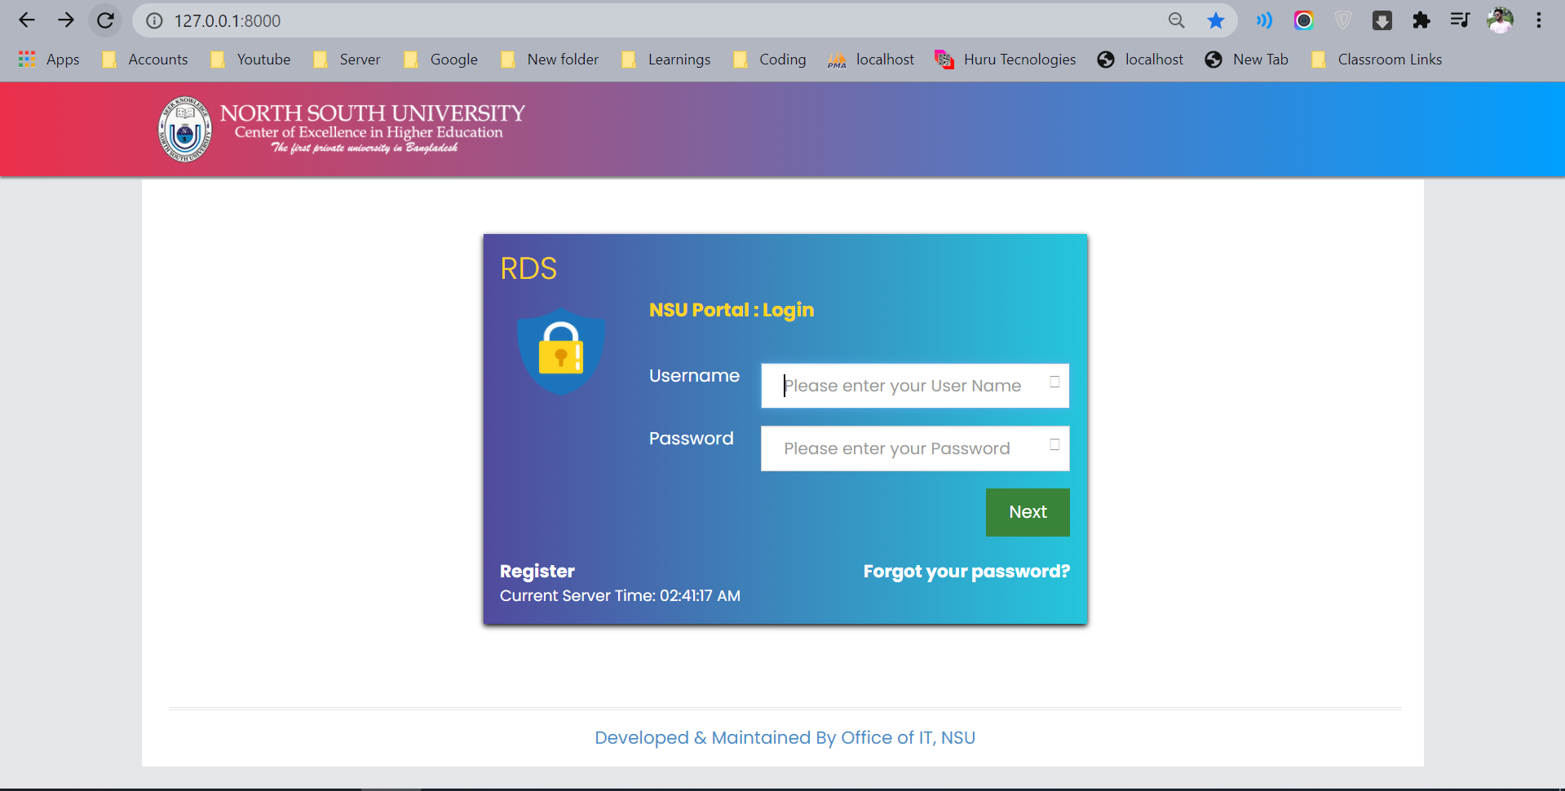

**Landing Page of Student Portal:**

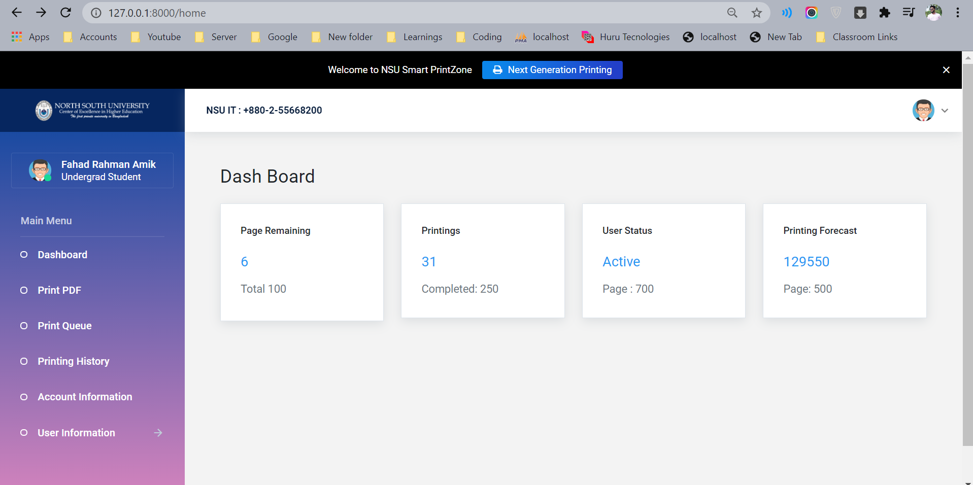

**Upload PDF :**

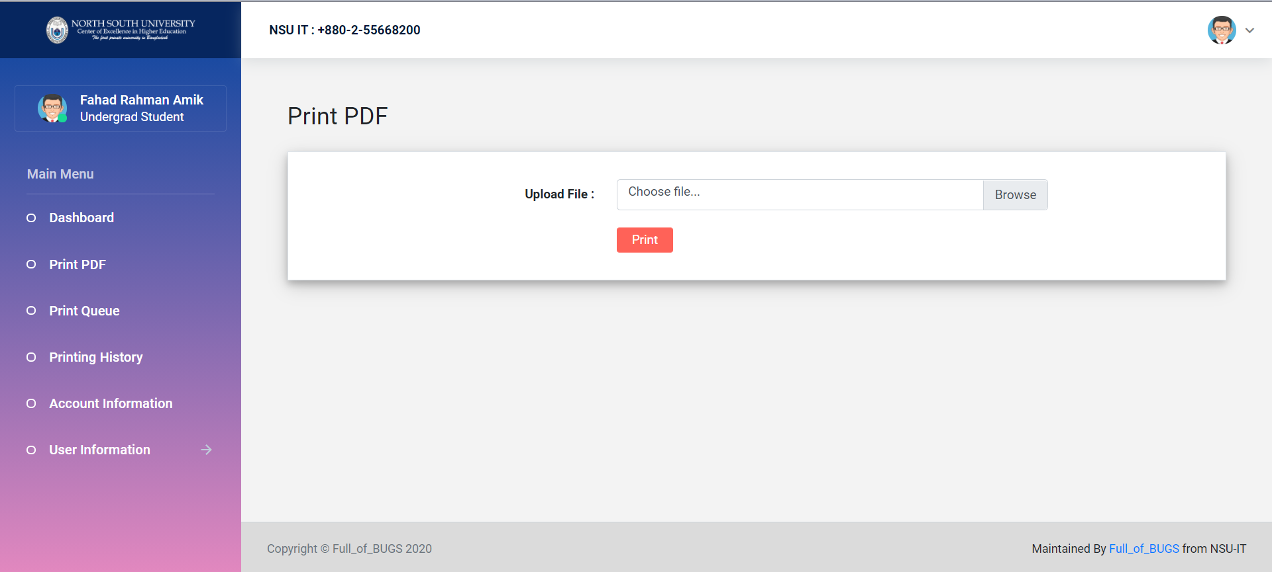

**Print Queue:**

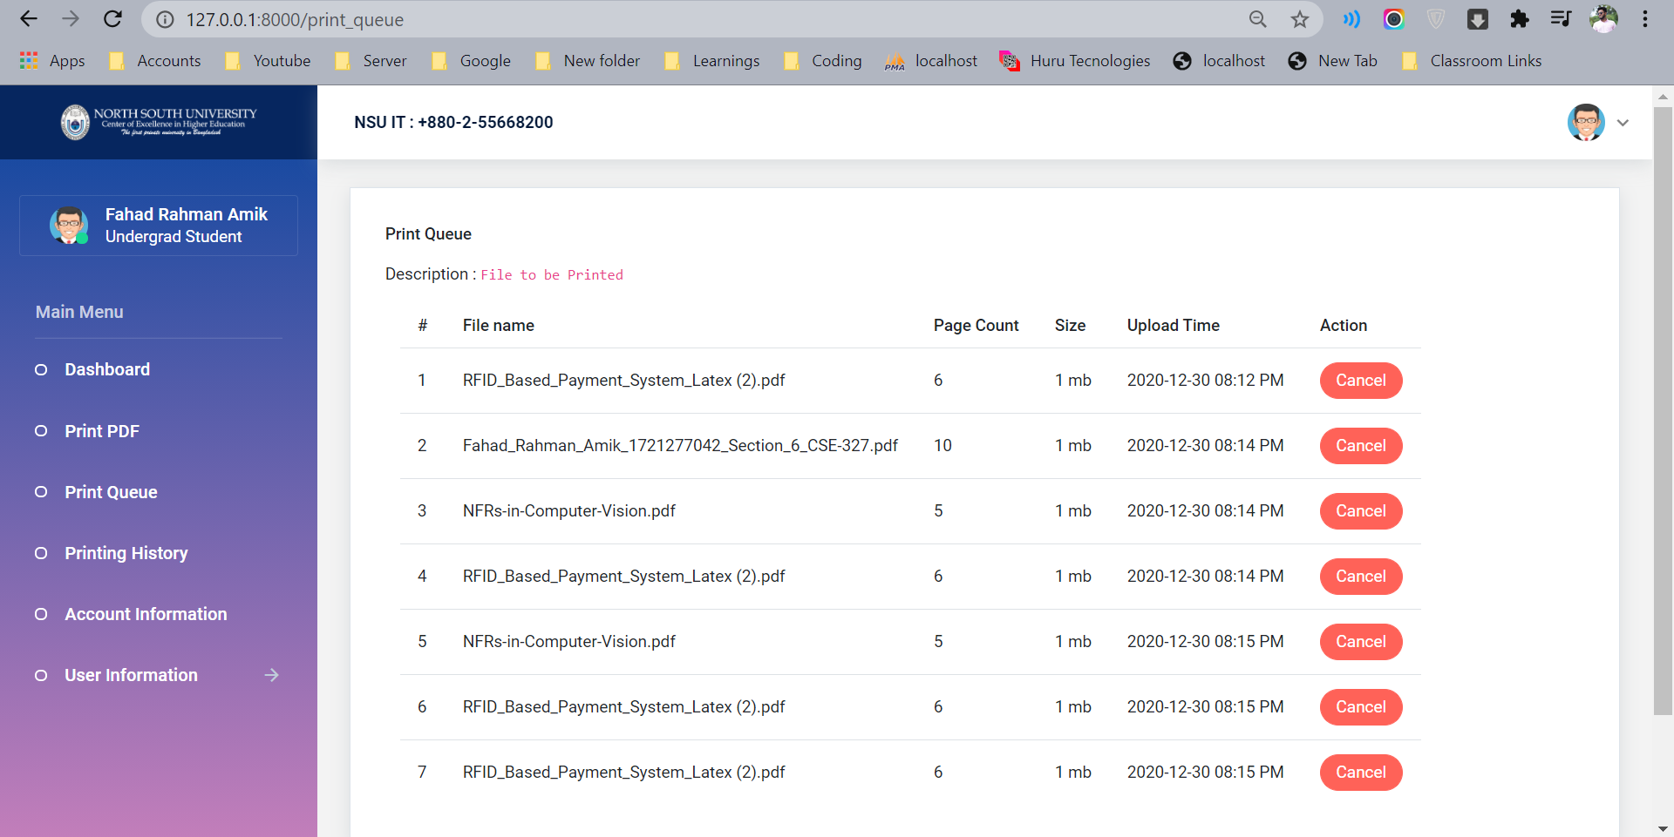

**Client Desktop App:**

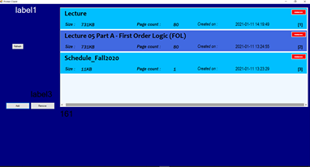

# 

# 

# 

# 

# 

# 

# 

# 

# **System Designs:**

## Diagram:

This following diagram is our whole system diagram.

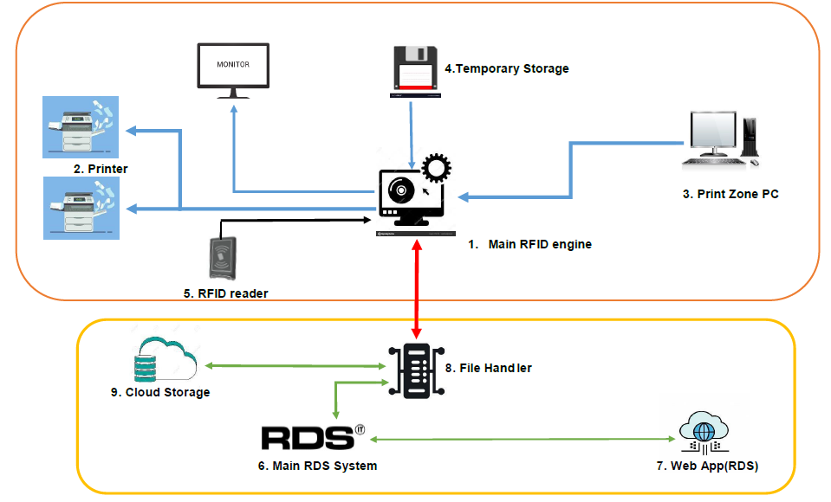

**Figure:** *NSU Smart PrintZone*

# **System architectural design:**

1. **Main RFID engine:** This is the core system (an ordinary PC with 16GB or more RAM and more than 8 core), which will be responsible for handling all print request and binding RFID punches to desired documents. Basically, it will be available offline, but it will maintain communication with file handler (which will be online) [refer to 8]. We don’t need a dedicated server PC here, because that will be over whelming for our need.
2. **Printer:** This is our normal printer. It will be connected to RFID engine According to our design, N number of new printers can be added here. (where 0<N<10). Our IT department is thinking of adding more printer on print zone and as well as on our Lounges. That will reduce pressure on print zone.
3. **Print Zone PC:** Our ordinary PCs, located on print zone, usually we do print from those. (around 100 in count)
4. **Temporary Storage:** This is basically a data storage (HHD/SSD) inside Main RFID engine PC. Requested documents (online/offline) will be stored here temporarily, as user punch their card, document will be printed immediately. As actual document will be on Print Zone pc(offline) or on RDS (online). During punch if the document is not available on this storage, then it must be downloaded from source (online/offline), which will generate time overhead. So, this storing is required to make printing job faster. Max 2TB storage will be sufficient. There is a good chance of generating some storage leak, our system design will handle it.
5. **RFID reader:** Usual RFID reader, as we see beside every NSU classroom door. There will be one reader for each printer, attached to it.
6. **Main RDS system:** Our as usual RDS system, to make printing system available online, our designed system will be connected to it. Just some API call, to make it accessible from RDS portal.
7. **Web app (RDS):** Our as usual RDS web app (user interface).
8. **File Handler:** RDS system will just redirect any print related request to it. Technically it is the main online part of our proposed system. It will handle online validation and uploading job. Also, will track printing status to make users print details available online. Also, it will maintain communication with Main RFID Engine to track live updates.
9. **Cloud storage:** It is another temporary storage like [4], what we mentioned earlier. Difference is, it will be an online storage rather than offline. It will store all online uploads temporarily. RFID engine [1] will request for any user’s document to File Handler, and Handler will transfer that file/files from this Cloud Storage.

## **System design and implementation challenges and how they have been addressed:**

Our idea is to develop such a system, which can handle those issues and add additional time and cost saving features to it. As NSU has RFID card, on our proposed system will take advantage from it. Main Idea is, user will print document as they did before. Additionally, there will be RFID card reader attached to our printers. Here, documents will not be printed directly after getting print command from PC. Our system will hold it. After giving print command, user will sign out their account and go beside printer, punch his/her NSU id card, after that, printer will print only that users document, immediately. So, there will be no pile of printed documents. Here, theoretically user will bound to maintain a queue on their own. First come (to printer) first serve. Now comes the additional feature, every NSUers has their RDS account. Our proposed printing system will be connected to it. User will upload their documents to print account, through RDS. Whenever user punch their card from printer, there document will be printed immediately. Means our printing system will be available online. They can upload document from home, and print it from University. They can check there printing status (page left, total printed page and many more) on RDS. They can use their phone, so the printing job will be more flexible and fun. One remarkable feature of our system is, it doesn’t require any additional dedicated RFID printer (cost around 8 lac taka each), existed printers will be sufficient for it. Only additional RFID receiver will be needed as our design. Our software will handle those matching and mapping job. Not additional hardware, means no need of additional human resource to handle the system. Our existed manpower will be sufficient enough. Yes, there will be many drawbacks, our software will handle those. For example, bad user can try to upload tempered (effected) documents, but our system will check every document before doing upload job. And so on.

# **Database design / Hardware Component Description:**

The following schema is for our web app. Though it is not final. We have to bring some changes in next semester for growing requirements.

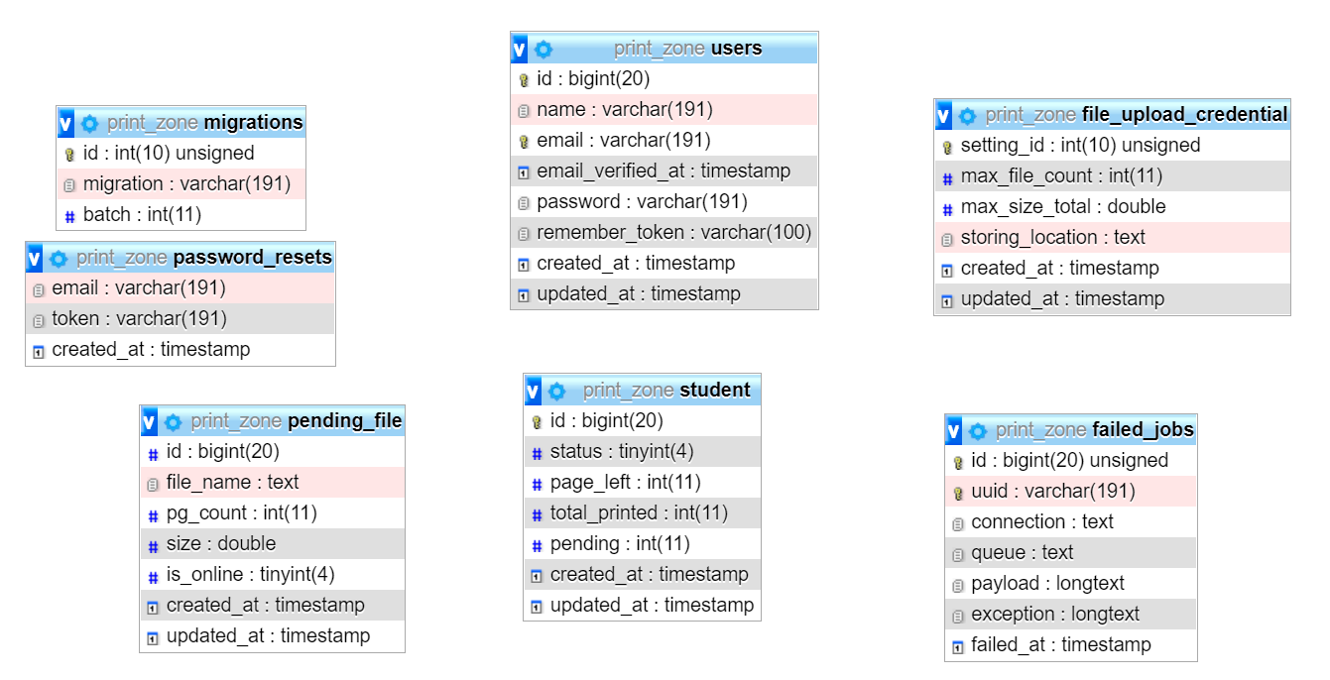

Figure: Web App Database Schema

# **UML diagram and Use Case Diagram:**

The following diagram is our system’s RFID engines use case diagram

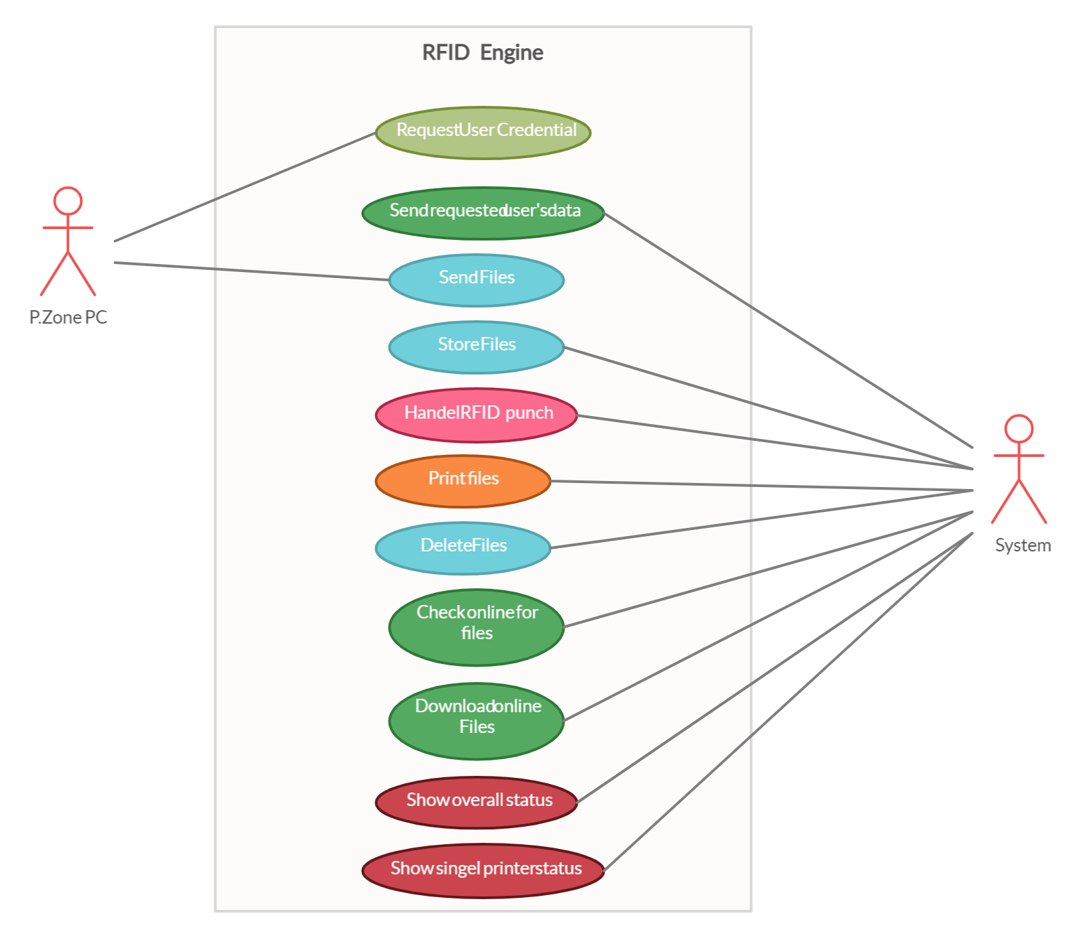

Figure: RFID Engine’s Use case diagram

The Following diagram is our client system’s use case diagram

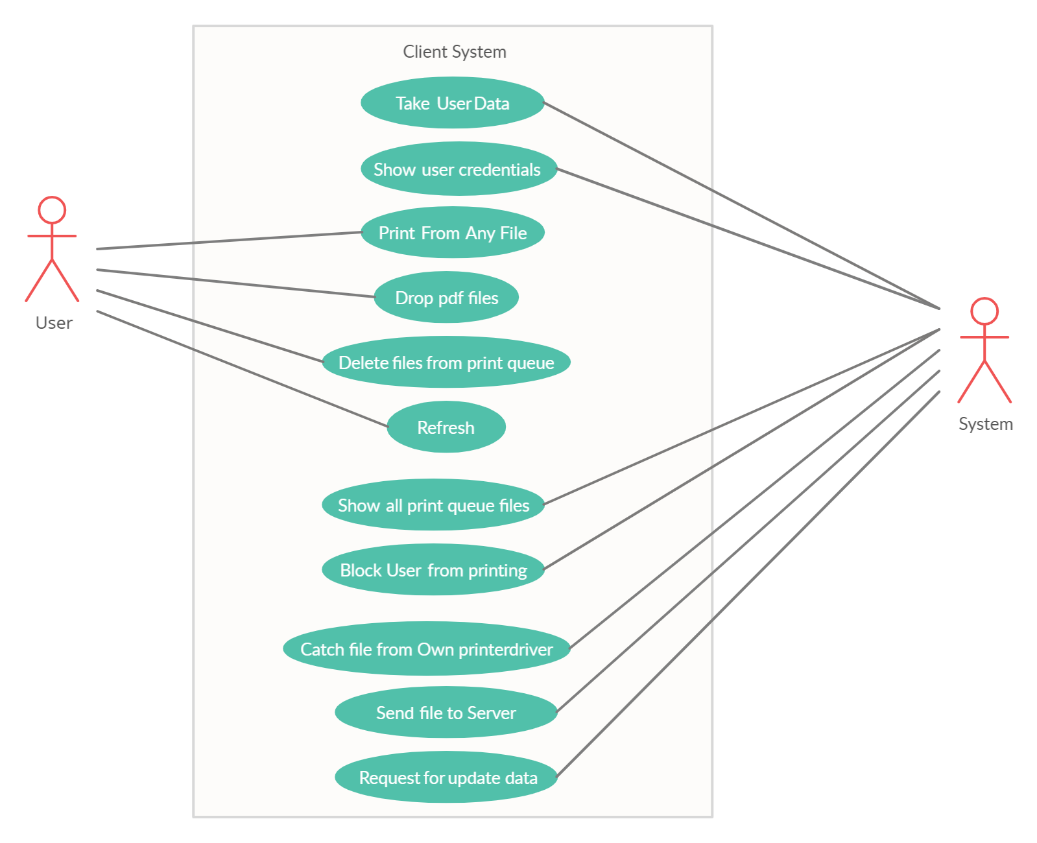

Figure: Client System’s Use case diagram

The Following Diagram is our system’s UML Diagram

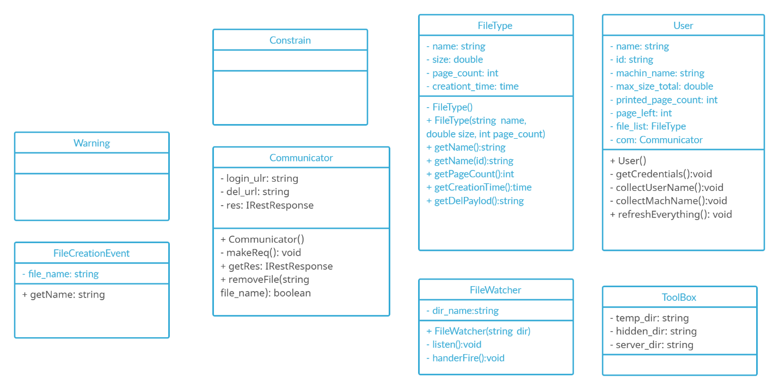

Figure : UML Diagram

**----------------------------------------------------Thank You--------------------------------------------**